 **BENHA UNIVERSITY**

**BENHA FACULTY OF ENGINEERING**

**DEPARTMENT OF ELECTRICAL ENGINEERING**

**Calculator using Embedded C**

**Submitted By:**

**Ahmed Mohsen Abouelyazed**

**Ahmed Lotfy El deep**

**Ibrahim Soliman Ibrahim**

**Ramadan Mahmoud Mohammed**

**Shaker Mohammed Shaker**

**Ahmed Ehab Mahmoud**

**Felopater nagy shokry**

*Power & Control Engineering, Department of Electrical Engineering,*

*Benha Faculty of Engineering, Benha University*

**Supervised By:**

**Dr. Ahmed El- Awamry**

*Department of Electrical Engineering, Benha Faculty of Engineering, Benha University, Benha*

# Abstract

A

ssembly code written from scratch to implement a basic calculator that performs the four basic operations: addition, subtraction, multiplication and division. An Initial message appears at the beginning to confirm to the user that our calculator functions efficiently. An operand-length limit is set to be 2 digits with the possibility to enter only one digit when desired. A remainder up to 4 digits after decimal point are provided in division operation result. There is also “ANSWER” feature which saves the result of current operation to be used in the next operation. Various error detection checkpoints to catch errors are added in order to avoid faults and wrong outputs. And also, the output is displayed up to 4 digits.

# Flow chart

# Simplified Block diagram

# Detailed Circuit

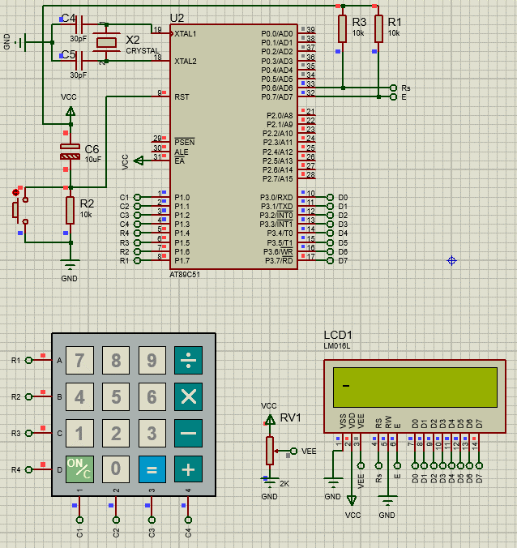

# Assembly Code

#include <reg51.h>

#define max 9

#define LCD_PORT P3

sbit rs=P0^6;

sbit e=P0^7;

#define keyport P1

unsigned char colloc, rowloc;

unsigned char keypad[4][4];

void lcd_command(unsigned char x);

void lcd_init();

void lcd_data(unsigned char x);

void lcd_delete();

void delay(unsigned char x);

unsigned char key_detect();

char scr;

//*********************************************************************************

typedef struct Stack

{

char top;

signed int items[max];

} stack;

void reset(stack *a)

{

a->top=-1;

}

void push(int pushed,stack *a)

{

a->items[++a->top]=pushed;

}

signed int pop(stack *a)

{

return a->items[a->top--];

}

signed int peek(stack a)

{

return a.items[a.top];

}

signed int underpeek(stack a)

{

return a.items[a.top-1];

}

signed int returnintresult(stack a)

{

return a.items[0];

}

signed int returnfloatresult(stack a)

{

return a.items[2];

}

//*****************************************************************************************************

char Priority(char val)

{

if(val=='+'||val=='-')

return 1;

else if(val=='*'||val=='/')

return 2;

else

return 0;

}

/*******************************************************************************************************

********************************************************************************************************/

void main()

{

unsigned char x;

signed int digits [19];

char digit_counter;

char numalpha ;

stack alpha;

char evaluation;

long firstoperator;

long secoundoperator;

signed int firstfloat;

signed int secoundfloat;

signed int resultfloat;

signed int resultint;

signed int ans_int;

signed int ans_float;

start:

scr=0;

digit_counter=0;

x='0';

evaluation=0;

numalpha = 3;

reset(&alpha);

P3=0xff;

lcd_init();

x=key_detect();

ans_label:

while (x!='=')

{

while(x=='.')

{

lcd_data(x);

digits[digit_counter++]=x;

numalpha=1;

x=key_detect();

}

lcd_data(x);

if (x>='0'&&x<='9')

{ x=x-0x30;

if (numalpha==0)

digits[digit_counter-1]=digits[digit_counter-1]*10+x;

else

digits[digit_counter++]=x;

numalpha=0;

}

else

{

if(numalpha!=0)//if operation pressed at the bggenning we push 0

digits[digit_counter++]=0;

if(Priority(x)>Priority(peek(alpha)))

push(x,&alpha);

else

{

digits[digit_counter++]=pop(&alpha);

push(x,&alpha);

}

numalpha=1;

}

x=key_detect();

}

while(alpha.top!=-1)

{

digits[digit_counter++]=pop(&alpha);

}

digits[digit_counter]='$';

lcd_data(x);

reset(&alpha);

while(digits[evaluation]!='$')

{

if (digits[evaluation]=='+'||digits[evaluation]=='-'||digits[evaluation]=='*'||digits[evaluation]=='/')

{

if (underpeek(alpha)=='.')

{

secoundfloat=pop(&alpha);

if (secoundfloat/10==0)

secoundfloat*=10;

pop(&alpha);

secoundoperator=pop(&alpha);

}

else

{

secoundoperator=pop(&alpha);

secoundfloat=0;

}

if (underpeek(alpha)=='.')

{

firstfloat=pop(&alpha);

if (firstfloat/10==0)

firstfloat*=10;

pop(&alpha);

firstoperator=pop(&alpha);

}

else

{

firstoperator=pop(&alpha);

firstfloat=0;

}

switch (digits[evaluation])

{

case '+':

resultfloat=firstfloat+secoundfloat;

resultint=firstoperator+secoundoperator+(resultfloat/100);

resultfloat=resultfloat-((resultfloat/100)*100);

push(resultint,&alpha);

push('.',&alpha);

push(resultfloat,&alpha);

break;

case '-':

if(firstfloat<secoundfloat)

{

firstfloat+=100;

firstoperator--;

}

resultfloat=firstfloat-secoundfloat;

resultint=firstoperator-secoundoperator;

push(resultint,&alpha);

push('.',&alpha);

push(resultfloat,&alpha);

break;

case '*':

firstoperator=firstoperator*100+firstfloat;

secoundoperator=secoundoperator*100+secoundfloat;

resultfloat=firstoperator*secoundoperator%10000;

resultint=firstoperator*secoundoperator/10000;

push(resultint,&alpha);

push('.',&alpha);

push(resultfloat,&alpha);

break;

case '/':

{

firstoperator=firstoperator*100+firstfloat;

secoundoperator=secoundoperator*100+secoundfloat;

resultfloat=((firstoperator%secoundoperator)*100)/secoundoperator;

resultint=firstoperator/secoundoperator;

push(resultint,&alpha);

push('.',&alpha);

push(resultfloat,&alpha);

}

}}

else

push(digits[evaluation],&alpha);

evaluation++;

}

resultint=returnintresult(alpha);

ans_int=resultint;

resultfloat=returnfloatresult(alpha);

ans_float=resultfloat;

if(resultint<0)

{

lcd_data('-');

resultint=0x10000-resultint;

}

reset(&alpha);

while(resultint!=0)

{

push(resultint%10,&alpha);

resultint/=10;

}

if (alpha.top==-1)

push(0,&alpha);

while(alpha.top!=-1) //to display integer nums

{

lcd_data(pop(&alpha)+0x30);

}

lcd_data('.');

while(resultfloat!=0)

{

push(resultfloat%10,&alpha);

resultfloat=resultfloat/10;

}

if (alpha.top<1)

push(0,&alpha);

while(alpha.top!=-1) //to display integer nums

{

lcd_data(pop(&alpha)+0x30);

}

x=key_detect();

if(x=='/'||x=='*'||x=='+'||x=='-')

{

reset(&alpha);

lcd_init();

lcd_data('A');

lcd_data('N');

lcd_data('S');

digit_counter=0;

digits[digit_counter++]=ans_int;

digits[digit_counter++]='.';

digits[digit_counter++]=ans_float;

numalpha=0;

scr=4;

evaluation=0;

goto ans_label;

}

else

goto start;

}

/*******************************************************************************************************

*********************************************************************************************************/

void delay(unsigned char itime)

{

unsigned char j;

{

for (j=0;j<itime;j++);

}

}

//LCD INTERACING:

void lcd_command(unsigned char x)

{

LCD_PORT=x;

rs=0;

e=1;

x=0;

e=0;

delay(255);

}

void lcd_init()

{

lcd_command(0x38); //8bits & 2lines

lcd_command(0x0e); // display on cursor blinking

lcd_command(0x01); // clear screen

lcd_command(0x80); //force curcor to 1st line

}

void lcd_data(unsigned char x)

{

scr++;

if (scr>15)

lcd_command(0x18);

LCD_PORT=x;

rs=1;

e=1;

delay(255);

e=0;

}

unsigned char keypad[4][4] = {{'.','7','4','1'},

{'0','8','5','2'},

{'=','9','6','3'},

{'+','-','*','/'} };

unsigned char key_detect()

{

keyport=0xF0; /*set port direction as input-output*/

do

{

keyport = 0xF0;

colloc = keyport;

colloc&= 0xF0; /* mask port for column read only */

}while(colloc != 0xF0); /* read status of column */

do

{

do

{

delay(20); /* 20ms key debounce time */

colloc = (keyport & 0xF0); /* read status of column */

}while(colloc == 0xF0); /* check for any key press */

delay(1);

colloc = (keyport & 0xF0);

}while(colloc == 0xF0);

while(1)

{

/* now check for rows */

keyport= 0xFE; /* check for pressed key in 1st row */

colloc = (keyport & 0xF0);

if(colloc != 0xF0)

{

rowloc = 0;

break;

}

keyport = 0xFD; /* check for pressed key in 2nd row */

colloc = (keyport & 0xF0);

if(colloc != 0xF0)

{

rowloc = 1;

break;

}

keyport = 0xFB; /* check for pressed key in 3rd row */

colloc = (keyport & 0xF0);

if(colloc != 0xF0)

{

rowloc = 2;

break;

}

keyport = 0xF7; /* check for pressed key in 4th row */

colloc = (keyport & 0xF0);

if(colloc != 0xF0)

{

rowloc = 3;

break;

}

}

if(colloc == 0xE0)

{

return(keypad[rowloc][0]);

}

else if(colloc == 0xD0)

{

return(keypad[rowloc][1]);

}

else if(colloc == 0xB0)

{

return(keypad[rowloc][2]);

}

else

{

return(keypad[rowloc][3]);

}

}

# PROTEUS Simulations and Results

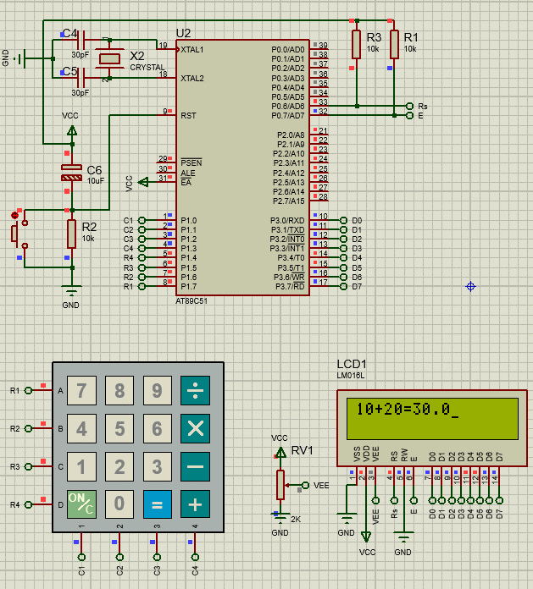**Addition Operation**

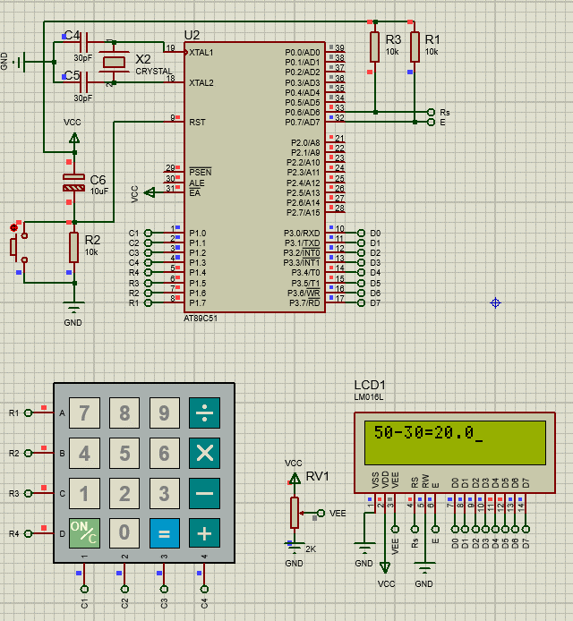**Subtraction Operation**

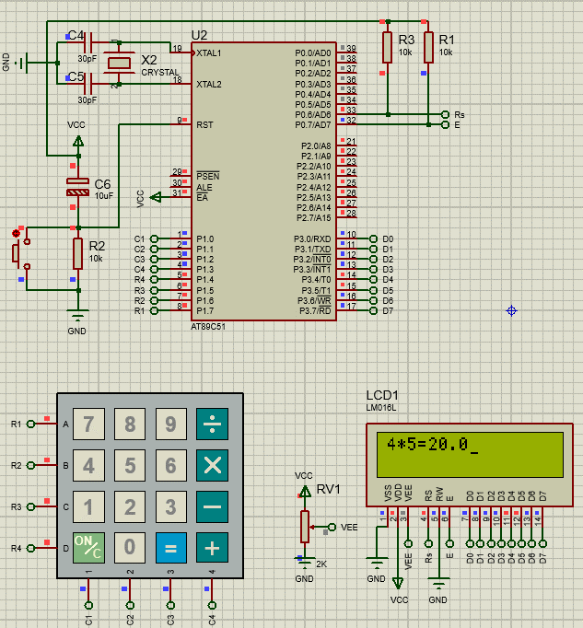**Multiplication Operation**

**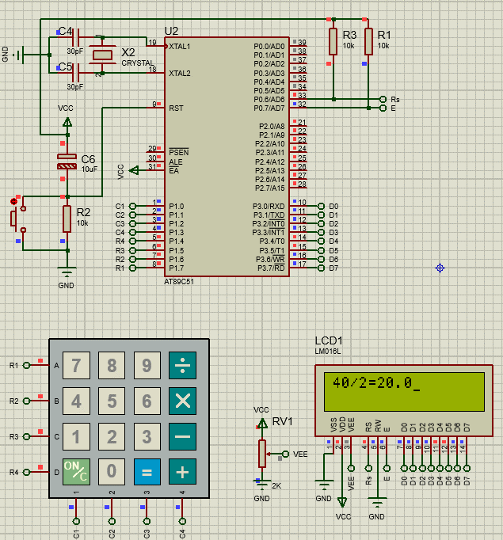Division Operation**

# Multiple digit Inputs and Multiple digits output (feature)

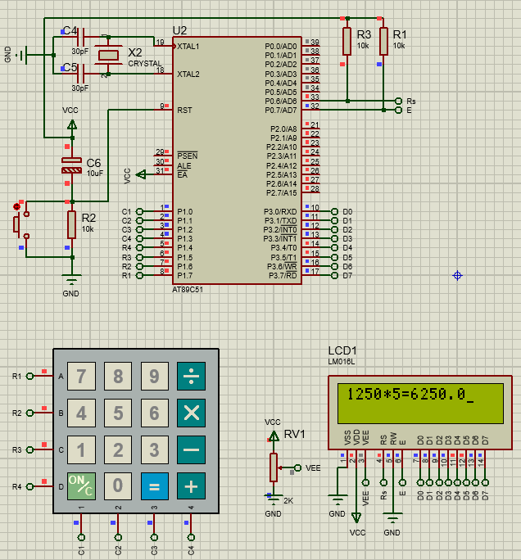

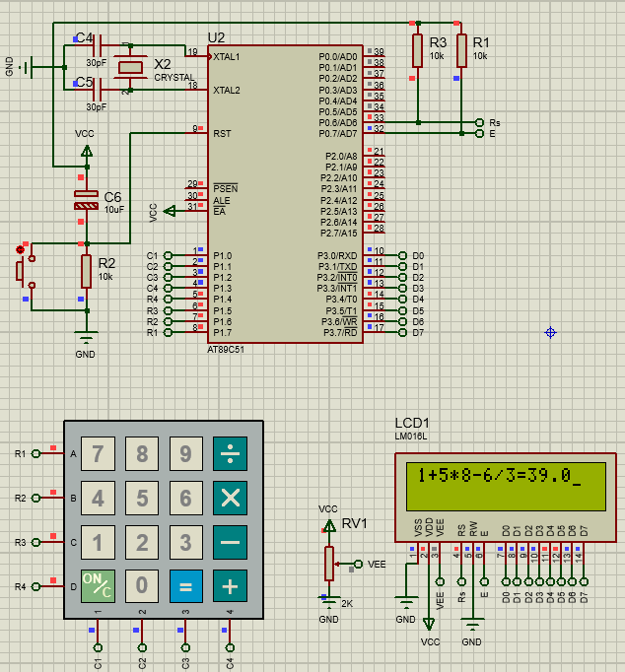**Multiple Operations at the same time (feature)**

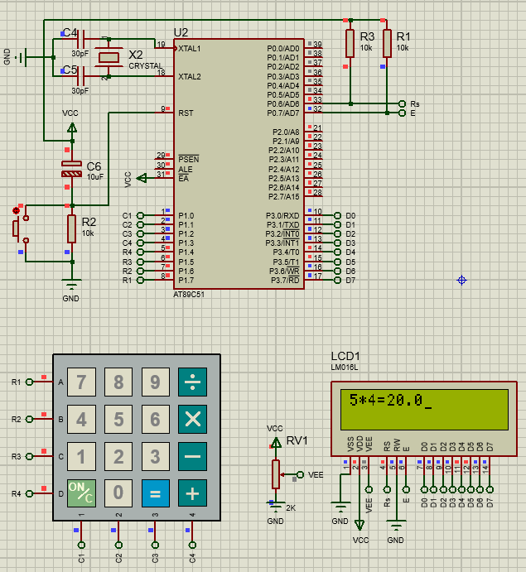**“ANS” feature**

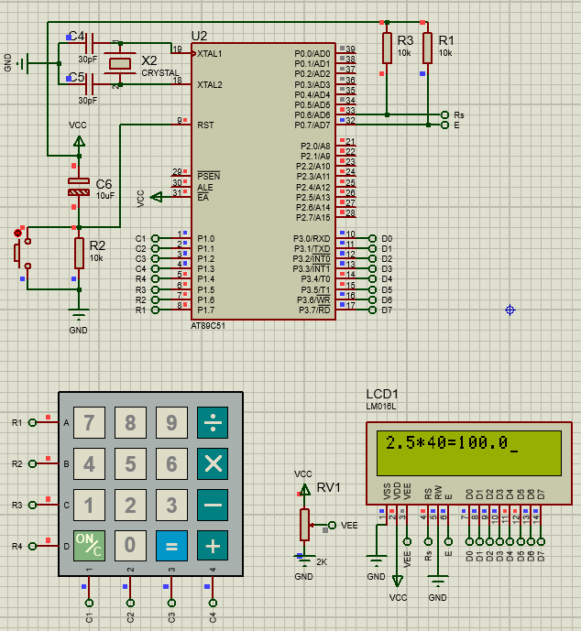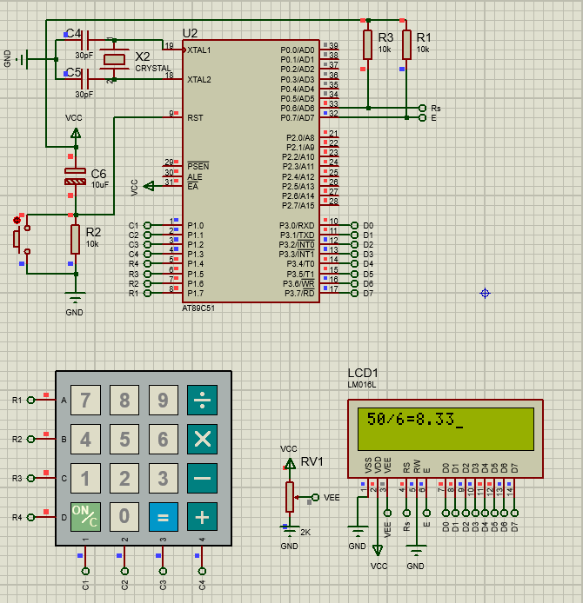**Floating Point Input or/and Output (feature)**

# Hardware documentation